Dashboard Design - Snowflake / Streamlit
Date | 29 October 2026
Team ID | Individual Project - Ujjawal Rathod
Project Name | Electric Vehicle Market Performance & Insights
Maximum Marks | 5 Marks

Dashboard goal and audience
Provide a compact, interactive view of EV category demand, model-year trends, competitive fragmentation, battery adoption, driving range, customer satisfaction, and geography. This is a Snowflake-backed design concept for the data/analytics layer; the previously published project dashboard is in Tableau Public.
The following is a design wireframe, not a screenshot of a running Streamlit application or a live Snowflake result. KPI cards use dataset facts from the earlier project handoff; analytical chart panels should be connected to validated MART views.
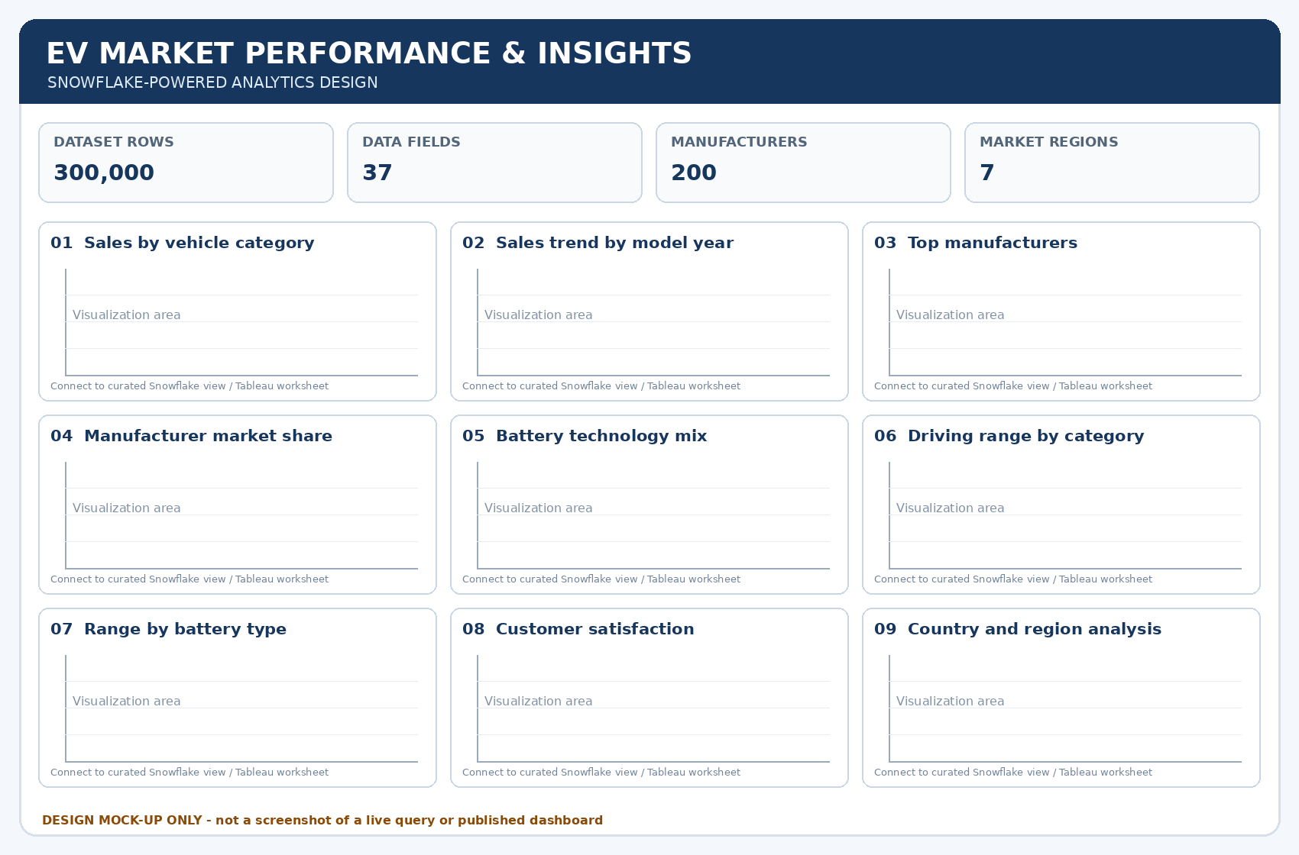

Layout and interaction specification
Area | Design choice | Purpose
KPI row | Dataset rows, columns, manufacturer count, market-region count | Establish the scope of the analysis without implying a live query was run.
Sales block | Category sales bar; model-year line; regional sales comparison | Identify leading categories and demand trends.
Competition block | Top manufacturers; market-share percentage | Show fragmentation using a stable all-market denominator.
Technology block | Battery share; range by category; range vs. energy consumption | Compare technology mix and performance trade-offs.
Customer / geography block | Rating by category; manufacturing country x market region heatmap | Support satisfaction and supply/geography analysis.
Filters | Model year, market region, vehicle category, battery type, manufacturer | Allow focused exploration; keep filter behavior consistent across charts.
Accessibility | Readable labels, color-blind-safe palette, tooltips, responsive single-column layout on narrow screens | Make the dashboard interpretable and robust.

Major outcomes to validate after implementation
• The prior project summary identified Two-Wheeler Scooter as a leading sales category; confirm the rank using the curated dataset.
• The manufacturer view should demonstrate fragmentation instead of exaggerating the leader by normalizing only the visible top ten.
• Battery technology mix should show NMC and LFP as the two largest groups in the prior summary.
• Driving range is expected to vary strongly by vehicle category; compare category and chemistry together.
• Customer satisfaction should be evaluated using the same 1-5 rating scale across categories.
• The dashboard should expose region and model-year filters while preserving consistent KPI definitions.

Data connections
Suggested Streamlit connection: use the Snowflake Python connector or Snowpark session and query EV_MARKET_DB.MART views. Do not embed passwords in the app; use Streamlit secrets or the deployment platform’s environment variables.

